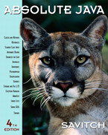 COSC 1320
Name: _________________ Terminal #__

Estimated Hours 1
Actual Hours

TA (Textual Analysis) for UML MVC CLASS Diagram MODEL
Programming Assignment 2:
(20 points.)
(due date found in the COSC 1320 BB Calendar!)
You must use Microsoft WORD program. Insert the TEMPLATEs for Actors and Use Cases in this Requirements Document.

Please have Step 1, 2, 3, 4, and 5 in this order.
Requirements Analysis: Construct the UML MVC CLASS Diagram MODEL

GUI PIZZA APPLICATION SWING

Write a GUI application program, to create a menu for a pizza shop. Use check boxes, radio buttons, and a JButton to allow a customer to make selections and process their order. Use a text area to display the customer’s order and the amount due. A sample menu and a customer’s order is shown in Figure below:

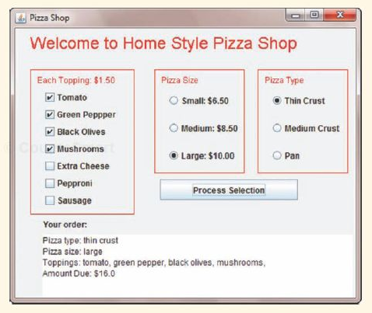

PLEASE DO NOT INCLUDE THESE PAGES AS YOUR DELIVERABLES! This is just for your use. Please have Step 1, then 2, etc. order in your deliverables.

UML LANGUAGE THAT MUST BE USED FOR TEXTUAL ANALYSIS!!!

UML MVC CLASS DIAGRAM MODELING:

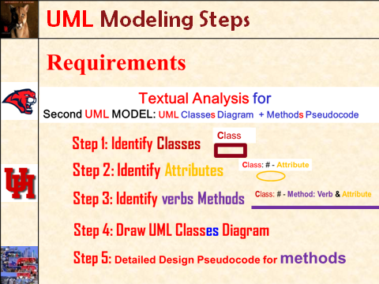

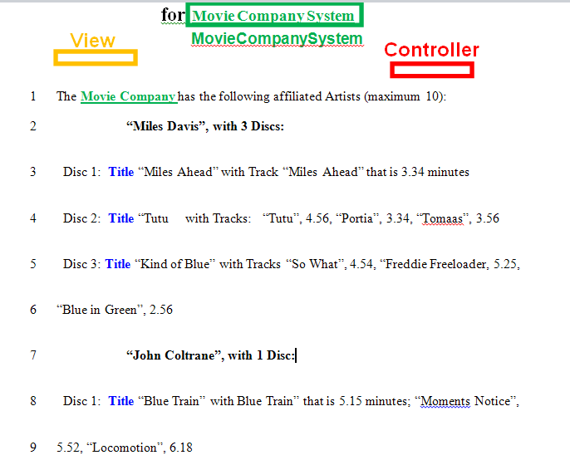
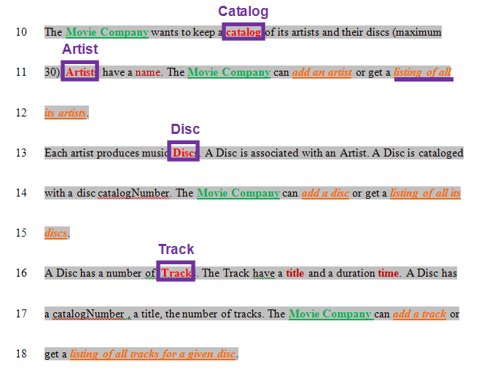
SEMANTICS: 
Class is a (first letter Upper Case) Noun.

TEMPLATE:
Class

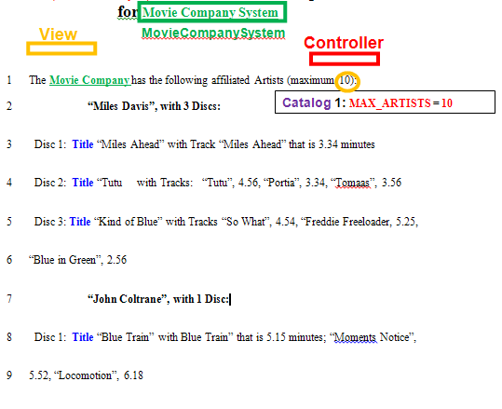
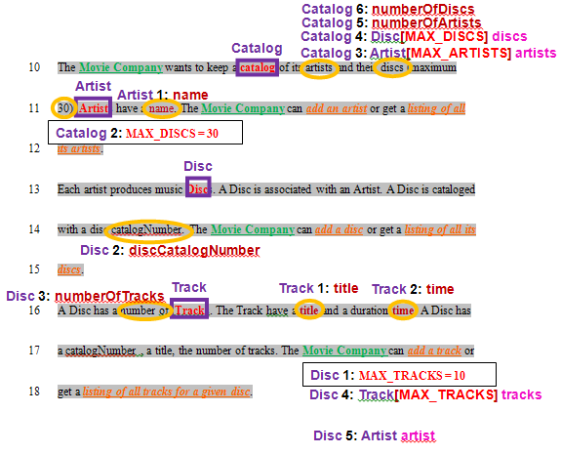
SEMANTICS: 
# - Attribute is a data Attribute for the Class and # counts Attributes for the Class

TEMPLATE:
Class: # - Attribute

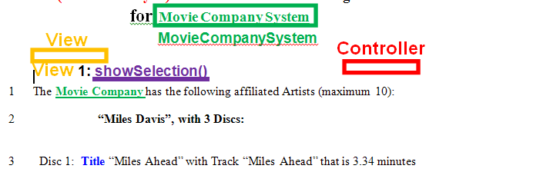
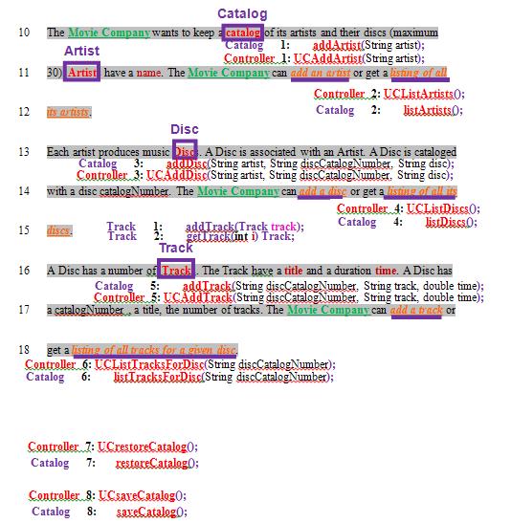
SEMANTICS: 
Method # is an operation on an Attribute for the Class and & is concatenation

TEMPLATE:
Class: # - Method: Verb & Attribute

